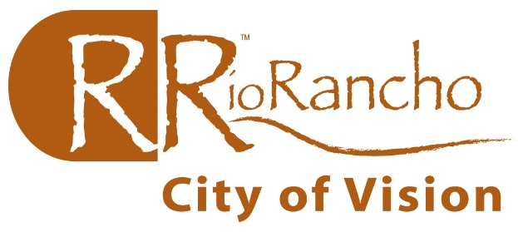
City of Rio Rancho
Development Services
3200 Civic Center Circle NE 1st Floor
Rio Rancho, NM 87144
(505) 891-5006 Fax (505) 896-8994
Permits@rrnm.gov

INSPECTION REQUEST FORM

CONTRACTOR NAME _________________________ SENT BY: __________________
PH: ________________ FAX:_______________ EMAIL:_________________________
PLEASE COMPLETE THE FOLLOWING INFORMATION FOR INSPECTIONS REQUEST
**ALL COLUMNS SHOULD BE COMPLETED FOR YOUR REQUEST TO BE ENTERED PROPERLY**
CUT OFF TIME FOR NEXT BUSINESS DAY INSPECTIONS IS 3:30 PM FOR FAX AND EMAIL

PERMIT# | INSPECTION TYPE | SITE ADDRESS

** YOU MAY USE SHEET FOR MORE THEN ONE ADDRESS **

